IBM Chapter 1 What is A Business, Concepts and Types

Section 1-1 What is a Business
Name:
Class Hour:

Objectives:
- I will be able to explain what a business is
- Learn what can be sold
- Differentiate between the four different types of businesses.

Business Definition:

Businesses sell Products: Products can be a or a or

Two Types of Products that can be sold:
List the type on the left, list the definition and examples on the right.

1. | Definition:  Examples from Notes:  Give 2 Additional examples of your own:
2 | Definition:  Examples:  Give 2 Additional examples of your own:

Some businesses sell both a Good and a Service. Below are two examples. Explain how it is a good and how it is a service. We will do the first together (the restaurant).

Table Talk Teamwork: Talk to your table and come up with a second answer to be shared with the class:

Example: | Explain the Good and the Service of your product
Restaurant | The good =  The service =
Table Talk Teamwork | The good =  The service =
Purpose of owning a Business:
# 1 Purpose

Quick Write Activity: Why would I own a Business?

Explain why you chose the top two from above?

What is Profit

Profit:

Profit Calculation:

Profit Examples:

Your REVENUE was $2000, your EXPENSES were $1200. How much is your profit?

Your EXENSES are $157,450, your REVENUE $200,000. How much is your profit?

Quick Write Activity:

If you could own your own business, what business would you open? Tell me what business and if you would sell goods, services or both. Describe at least two goods you would sell or the service you would sell in as much detail as you can.

What is Revenue?

Revenue Definition:

Revenue Sources: Revenue is earned from many sources. Several sources include:

Primary Source of revenue
1

1.
2
3
4
Other Sources

Expenses Definition:

Sources of Expenses:

How do Business use their revenue?

Operating Profit and Operating Loss
Profit:
Loss:
Quick Write Activity: In the space below, explain in your own words the difference between a profit or a loss in the world of business.

Positives of Business Negative of business:

Quick Write Activity:
Read the article in the Presentation regarding General Motors and answer the question below:

From what you read, if this business activity by GM occurred, do you feel this is acceptable and ethical in the world of business? Why or why not? Explain in written format your opinion on the matter?

Is this business process a positive aspect, or negative aspect of the business environment?

Four Categories of Business and their definition:
Type Definition:

What is Business (IBM 1-1)

Definition Review: Using your activity packet, find the terms that match the definitions below to complete the Crossword puzzle. When completed, you need to show your instructor to receive her initials that it is completed during the timeframe provided in the classroom if you were present.
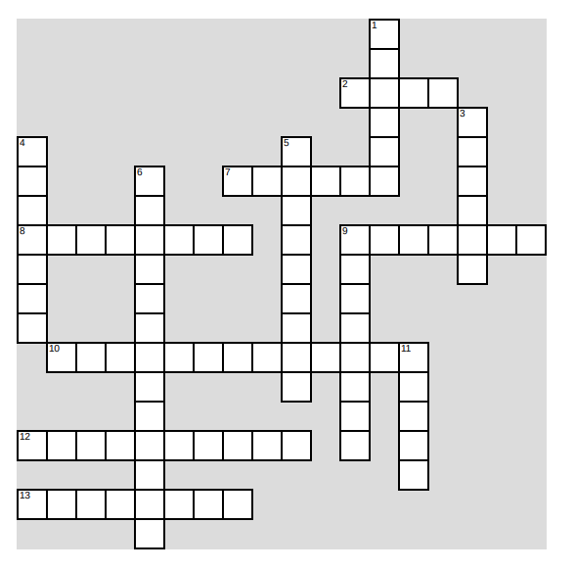

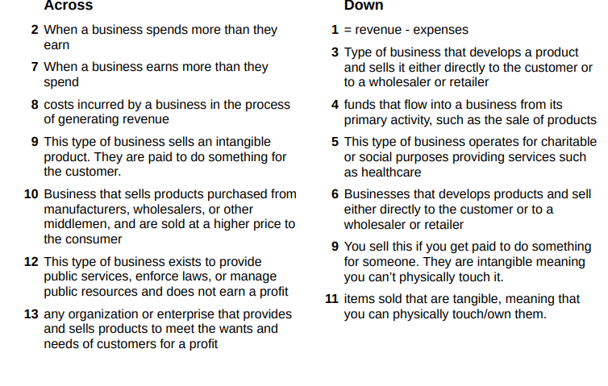
Businesses that don’t earn a profit:

Non-profit:

Two types of Non- Profit Organizations:

Definition:

What do they do:

Definition:

Examples

Lesson 1 – 2 What is Marketing
Marketing and The Marketing Concept
Objectives
- Define Marketing
- What is the Marketing Concept
- Wants Versus Needs

Table Talk:
- True of False: If you open a business, say a restaurant, you slap a name on it, build a location, and everyone will just automatically come because you created a business?
Discuss why or why not at your tables and enter your answer here:

Marketing Definition:

It is about understand customers and .

Marketing includes (to name a few activities there are more):

Marketing Concept

Difference between a Want and a Need:

Definition | Examples:
Want:

Need:

Assignment:
Directions: Go to Amazon’s website and make a list of five items that would be considered needs for you, and five items that would be considered wants for you. Next to each item, briefly explain why it would be considered a need or a want.
 | Price | Want or a Need | Why is
Example: Nike Air Force 1 for Men | $124 | Want | I need shoes, but I don’t have to spend this amount, I can get a different lower price option.  Or – This is a want because I already have a pair of shoes and don’t need a 2nd pair

Final Test Project:

When thinking about owing a business, we need

